**1.**

|  |  |  |
| --- | --- | --- |
| **N** | **N2** | **2N** |
| 5 | 52 = 25 | 25 = 32 |
| 6 | 62 = 36 | 26 = 64 |
| 7 | 72 = 49 | 27 = 128 |
| … | … | … |
| K | K2 | 2K |
| K + 1 | (K + 1)2 | 2K+1 |

Base Case: N = 5, 52 = 25 < 25 = 32

Inductive Hypothesis: Assume K2 < 2K

Inductive Proof: Prove that K2 < 2K implies that (K + 1)2 < 2K+1

K2 * 2 < 2K * 2 = 2K+1

(K + 1)2 = K2 + 2K + 1 < 2K2 🡨🡪 2K + 1 < K2

2K + 1 < K2 holds for K ≥ 5

K2 – 2K – 1 > 0, solve via quadratic formula, K > (2 + sqrt(2)) / 2

Therefore,(K + 1)2 < 2K+1

**2.**

|  |  |  |
| --- | --- | --- |
| **N** | **N!** | **2N** |
| 4 | 4! = 24 | 24 = 16 |
| 5 | 5! = 120 | 25 = 32 |
| 6 | 6! = 720 | 26 = 64 |
| … | … | … |
| K | K! | 2K |
| K + 1 | (K + 1)! | 2K+1 |

Base Case: N = 4, 4! = 24 > 24 = 16

Inductive Hypothesis: Assume K! > 2K

Inductive Proof: Prove that K! > 2K implies that (K + 1)!> 2K+1

K! > 2K

(K + 1)! = K! * (K + 1) > 2K * (K + 1)

2K * (K + 1) > 2K+1 = 2K * 2 for K + 1 > 2 🡪 K > 1

**3.**

**Any number greater than 11 can be written as (a * 4 + b * 5)**

Base Cases:

N = 12 = 3 * 4 + 0 * 5

N = 13 = 2 * 4 + 1 * 5

N = 14 = 1 * 4 + 2 * 5

N = 15 = 0 * 4 + 3 * 5

Inductive Hypothesis: Assume that there exists K > 11 can be written as (a * 4 + b * 5)

Inductive Proof:

Prove that K > 11 can be written as (a * 4 + b * 5) implies that K + 4 can be written as (A * 4 + B * 5)

K = (a * 4 + b * 5)

K + 4 = ( (a + 1) * 4 + b * 5 )

Our inductive proof together with our bases cases proves the statement. +4 and 4 consecutive base cases.

**Any number greater than 11 can be written as (a * 4 + b * 6)**

This does not work for all numbers greater than 11. If we have an odd number K, we cannot write K as (a * 4 + b * 6) because a * 4 is even and b * 6 is even, and the sum of two even numbers is even.

For example, let K = 13. K = 13 cannot be written as (a * 4 + b * 6).

**4.**

Base Cases:

N = 1, D(N = 1) = 1

N = 2, D(N = 2) = 2

N = 3, D(3) = D(2) + D(1) = 3

Inductive Hypothesis:

D(N) = D(N – 1) + D(N – 2)

Inductive Proof:

D(N + 1) = D(N + 1 – 1) + D(N + 1 – 2) = D(N) + D(N – 1)

To prove this consider the below picture:

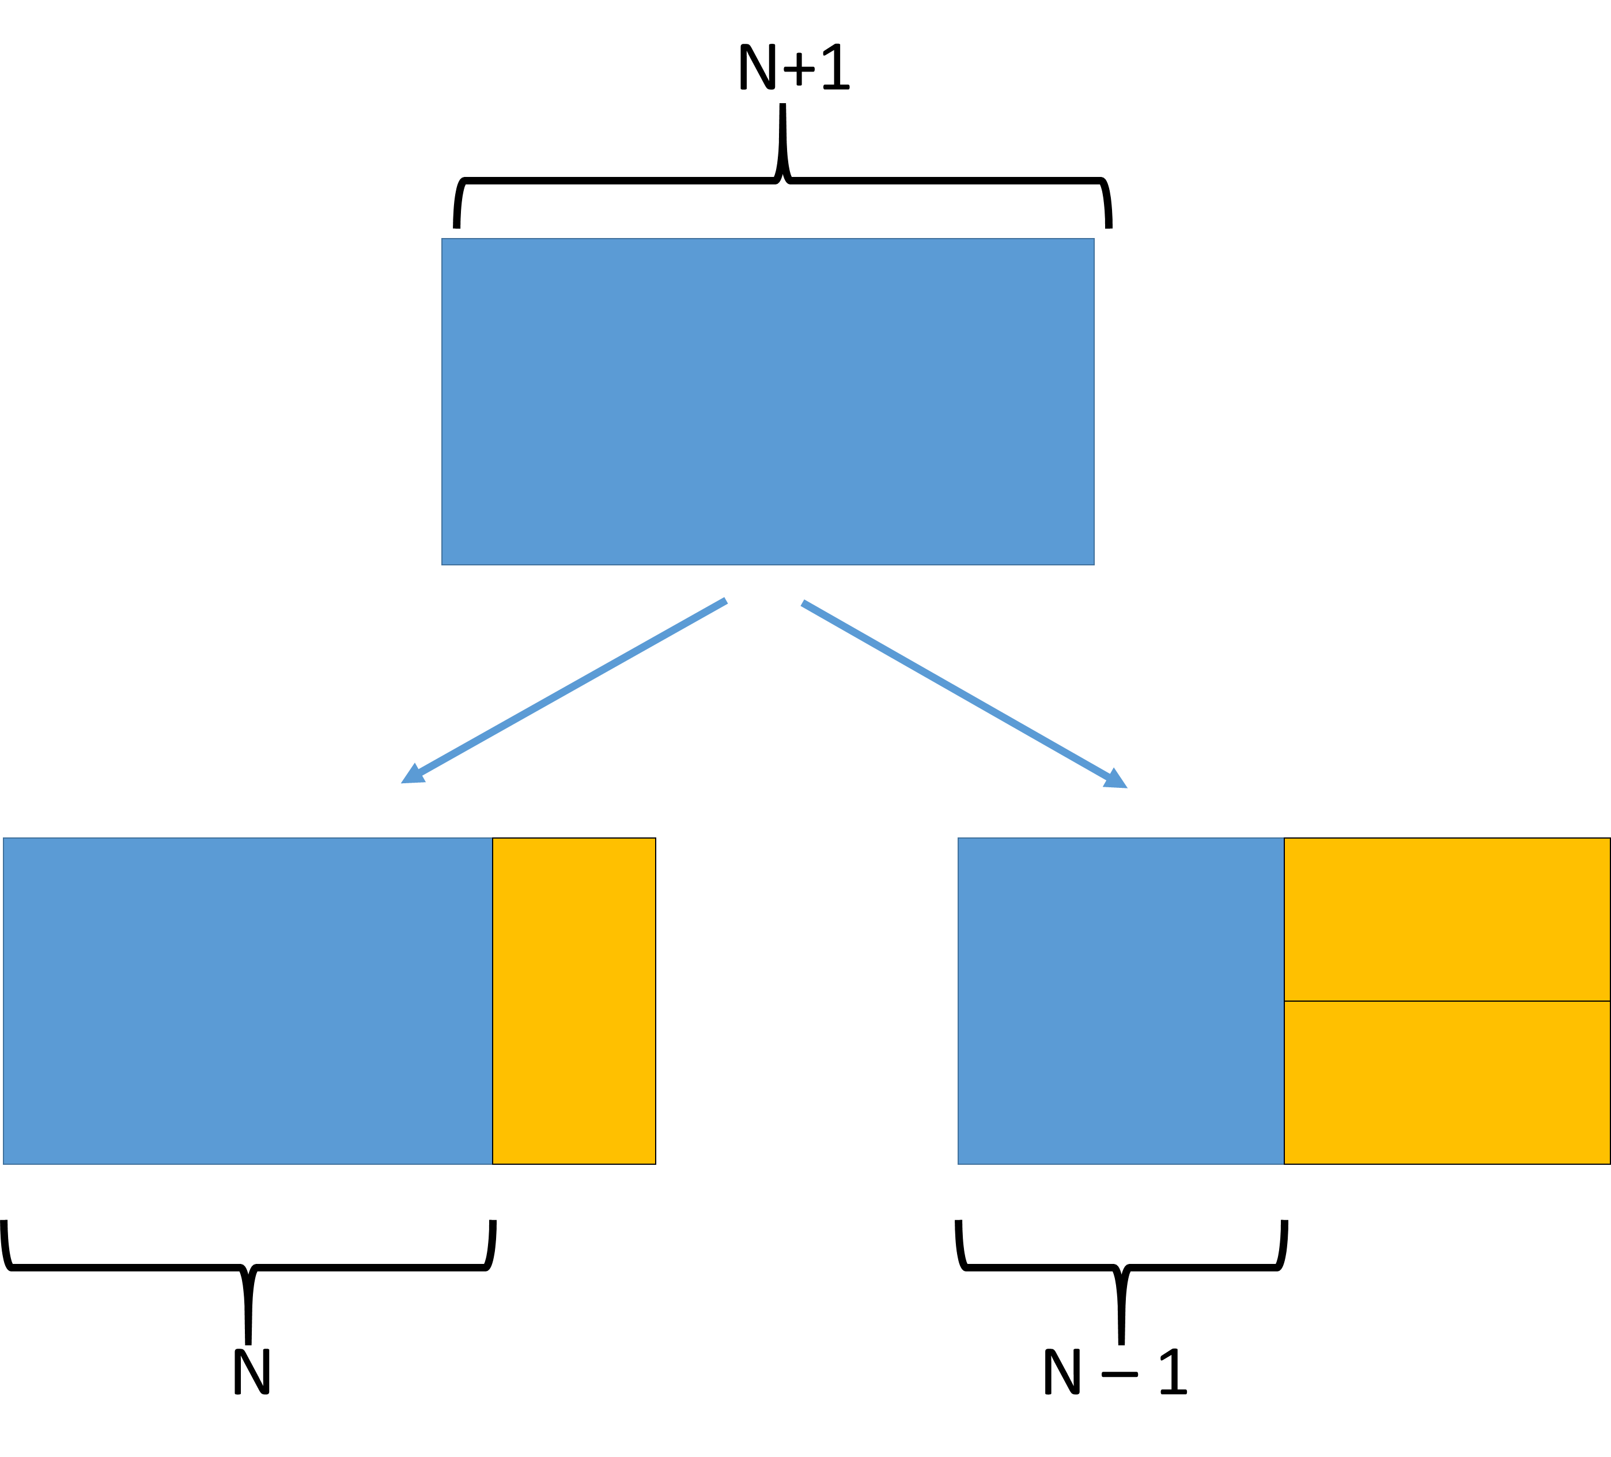

The number of tilings for a 2 X N + 1 rectangle is related to the number of tilings for a 2 X N and a 2 X N – 1 rectangle. If we choose to add one vertical domino, we are left with a tiling problem for 2 X N dominoes. If we choose to add two horizontal dominoes, we are left with a tiling problem for 2 X N – 1 dominoes. These two subcases are distinct because the dominoes are in different orientations.

Therefore, D(N) = D(N – 1) + D(N – 2), D(N = 1) = 1, D(N = 2) = 2

|  |  |  |  |
| --- | --- | --- | --- |
| **N** | **D(N)** | **(3/2)N** | **2N** |
| 1 | 1 | 1.5 | 2 |
| 2 | 2 | 2.25 | 4 |
| 3 | 3 | 3.375 | 8 |
| 4 | 5 | 5.0625 | 16 |
| 5 | 8 | 7.5938 | 32 |
| 6 | 13 | 11.3906 | 64 |
| 7 | 21 | 17.0859 | 128 |
| 8 | 34 | 25.6289 | 256 |
| 9 | 55 | 38.4434 | 512 |
| 10 | 89 | 57.6650 | 1024 |

From the table it can be seen that 2N > D(N) > (3/2)N for N > 4.

Base Case: N = 5

25 = 32 > D(5) = 8 > (3/2)5 = 7.59\

N = 6 base case too

Inductive Hypothesis: N = K

Let us assume that the relation holds up to N = K. That is, 2K > D(K) > (3/2)K and 2K-1 > D(K – 1) > (3/2)K-1

Inductive Proof: N = K + 1

To complete the proof we must show that the following is true: 2K+1 > D(K + 1) > (3/2)K+1

D(K + 1) = D(K) + D(K – 1)

First to prove 2K+1 > D(K + 1)

D(K) > D(K – 1)

D(K) + D(K) = 2 * D(K) > D(K – 1) + D(K) = D(K + 1)

2 * 2K = 2K+1 > D(K + 1)

Now to prove D(K + 1) > (3/2)K+1

D(K) + D(K – 1) > (3/2)K + (3/2)K-1

(3/2)K + (3/2)K-1 = (3/2)K * (1 + (3/2)-1) = (3/2)K *(5/3) > (3/2)K * (3/2) = (3/2)K+1

The proof is complete by induction.